North Warwickshire UKSPF Advisory Panel - Minutes
Wednesday 18 September 10am

Present: Cllr. D Wright (Chairperson), Cllr. Ridley, Cllr. Clews

Steve Maxey, Becky Evans, Lorraine Verrall (NWCA), Roger Minett (NWCA), Sarah Newell (WCAVA), Julie Davis (Arley Parish Council), Martin Langley (Arley Parish Council), Eric Fellows (Arley Parish Council), Dan Heaford (Skills Ladder).

Apologies for Absence: Cllr. Bell, Mary Dunleavy (DWP), Matthew Epps (WCC), William Tse (WCC), Charles Barlow (WCC),

Notes | Action
Overall Allocation

The Panel were reminded that the overall funding allocation for North Warwickshire is:

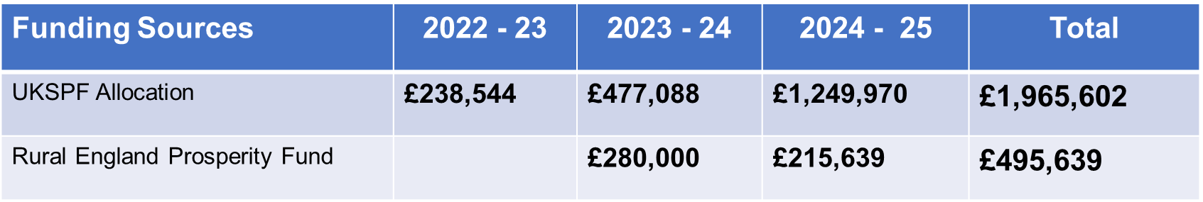
Allocations to Date

Total allocations to date:

 | Total allocation |  |  | Total left to allocate
 | 2022 / 23 | 2023 / 24 | 2024 / 25 | Total left to allocate
Communities & Place | £181,044 | £278,088 | £506,970 | £49,136
Local Business | £27,500 | £117,000 | £239,250 | £27,443
People & Skills | £30,000 | £82,000 | £503,750 | £341,835
Rural England |  | £280,000 | £215,639 | £283,947

The cost of administrative support also comes from the core UKSPF funding.

Matter Arising

Following their previous application, WCC had worked with officers from NWBC on their proposal for People & Skills. This has now been agreed.

Celebration Event

The Panel and all applicants are invited to attend a celebration event. The event has been organised to showcase the projects which have received UKSPF funding and highlight the achievements the funding has enabled.


Applications Received and Decisions

Replacement goal posts (NWBC) | APPROVED
Secure dog area (NWBC) | APPROVED subject to approval at C&E Board and consultation
Royal Meadow Drive K-Barrier (NWBC) | APPROVED
GPS Farm Tractor System (Fields Farm) | APPROVED
North Warwickshire Digital Pathways (Skills Ladder Ltd) | APPROVED
Traffic Management for Community Events (Atherstone Partnership) | DECLINED
School Attendance Project (WCC) | APPROVED
Dordon Village Hall Restoration (Dordon Parish Council) | APPROVED
North Warwickshire Museum and Community Hub (NW Museum and Community Hub Committee) | APPROVED
Green Escapes Project (Hood Lane Farm) | DECLINED
Hilltop Pavilion (Arley Parish Council) | APPROVED
Austrey Village Hall Improvements (Austrey Old School Hall Trust) | APPROVED

Future Meeting Dates

11 December 10am Committee Room

