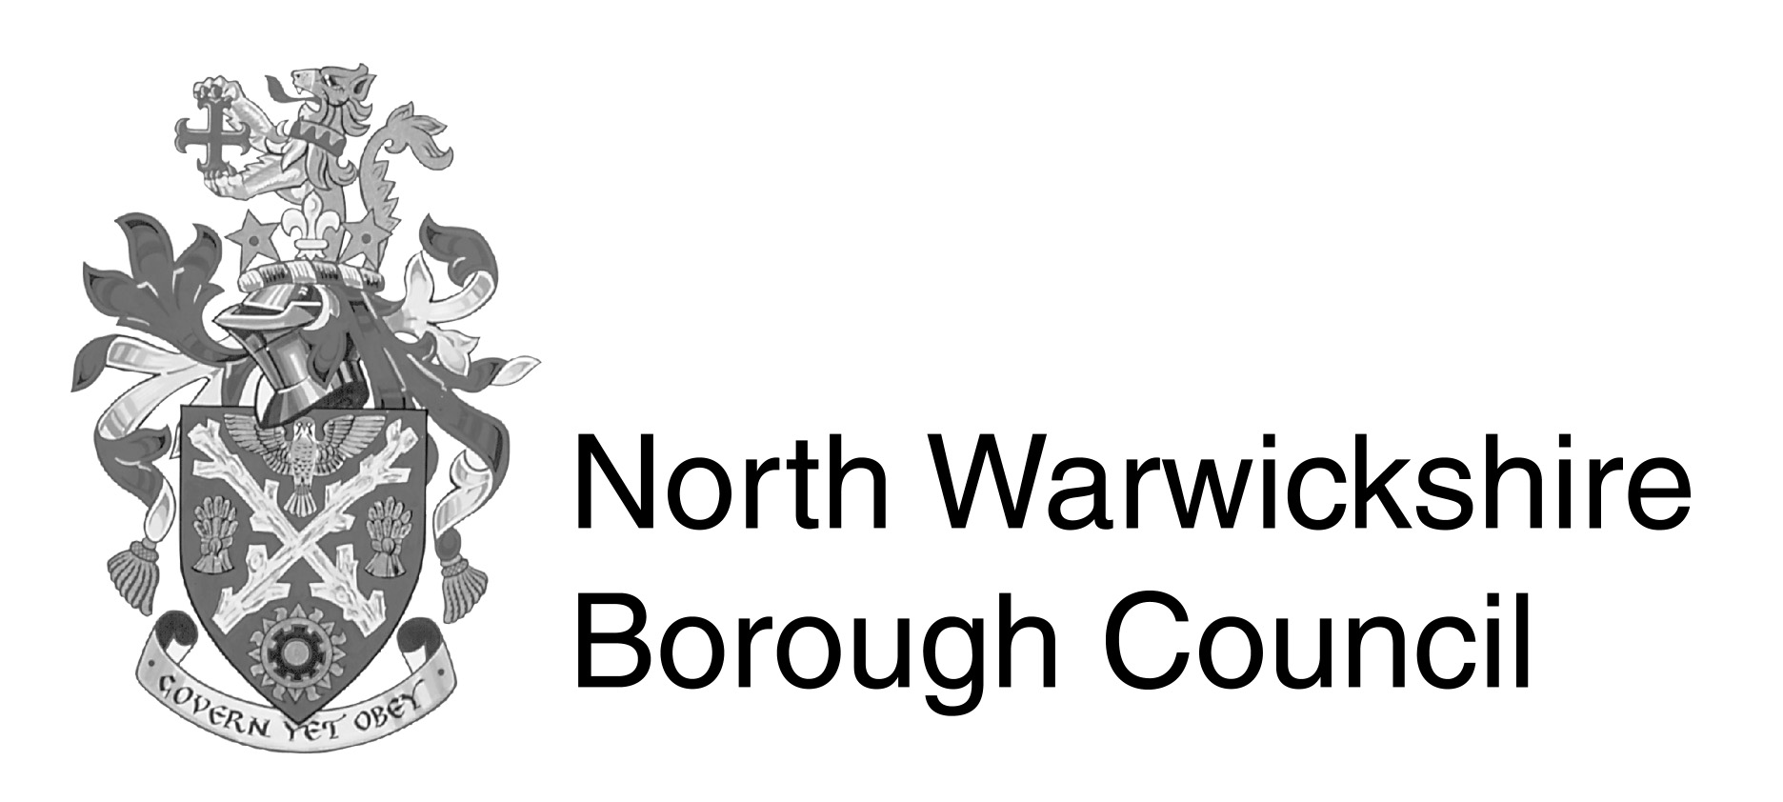 | Steve Maxey BA (Hons) Dip LG Solicitor  Assistant Chief Executive  and Solicitor to the Council  The Council House  South Street  Atherstone  Warwickshire  CV9 1DE  Switchboard : (01827) 715341  Fax : (01827) 719225  E Mail : planningpolicy@northwarks.gov.uk  Website : www.northwarks.gov.uk  This matter is being dealt with by  : Sue Wilson  Direct Dial : (01827) 719499  Your ref :  Our ref :
 | Date : 03/04/2025

Dear Kingsbury Parish Council

RE: DESIGNATION OF KINGSBURY NEIGHBOURHOOD AREA
S.61G OF THE TOWN AND COUNTRY PLANNING ACT 1990 (AS AMENDED)
THE NEIGHBOURHOOD PLANNING (GENERAL) REGULATIONS 2012

I write further to your application to North Warwickshire Borough Council for designation of a Neighbourhood Area for Kingsbury, which was received 13th February 2025.

This confirms that the Chief Executive has designated the area shown on the enclosed map as ‘Kingsbury Neighbourhood Area’, for the purposes of preparing a Neighbourhood Development Plan by KINGSBURY PARISH Council under S.61G(1) of The Town and Country Planning Act 1990 (as amended).

I would also like to thank you for your positive and proactive approach to Neighbourhood
Planning in Kingsbury. If you have any queries regarding this letter or would like to discuss your emerging Neighbourhood Plan, please do not hesitate to contact me on the above details.

Yours sincerely,

D M Barratt

Dorothy Barratt
Forward Planning and Economic Strategy Manager

