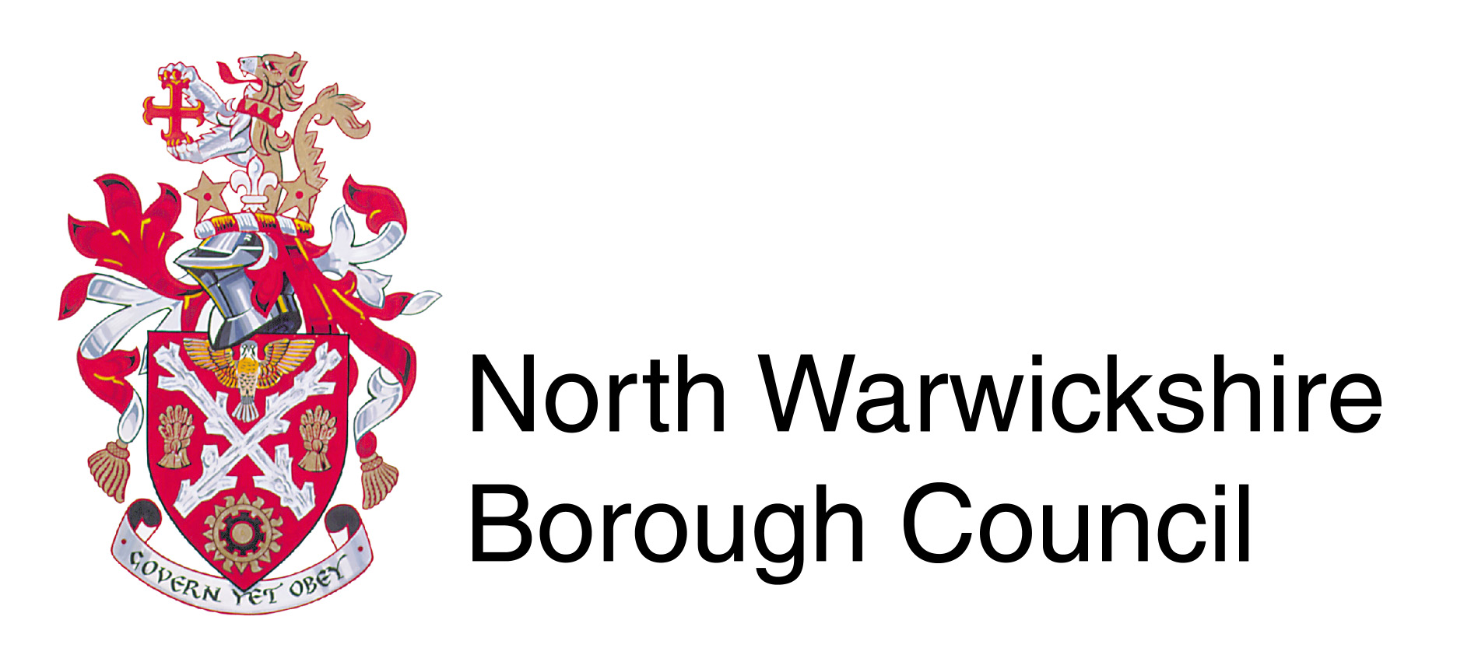
Licensing
North Warwickshire Borough Council
The Council House
South Street
Atherstone
CV9 1DE
Licensing Act 2003
Personal Licence replacement

1. Your personal details

TITLE Please tick 

Mr Mrs Miss Ms Other (please state)

Full name

Contact Tel:
Mobile:

ADDRESS

Reason for replacement

Please note this form should be returned with a copy of photo ID (passport, drivers licence), 2 x photos (passport size) and a fee of £10.50 paid by card or cheques made payable to North Warwickshire Borough Council Forms to be returned to:

Licensing
North Warwickshire Borough Council
South Street
Atherstone
CV9 1DE
Telephone – 01827 719217

An amended licence will be issued in due course.
FAILURE TO NOTIFY THE LICENSING AUTHORITY OF CHANGE OF NAME OR ADDRESS IS AN OFFENCE UNDER SECTION 127 OF THE LICENSING ACT 2003.

Sign

Date

