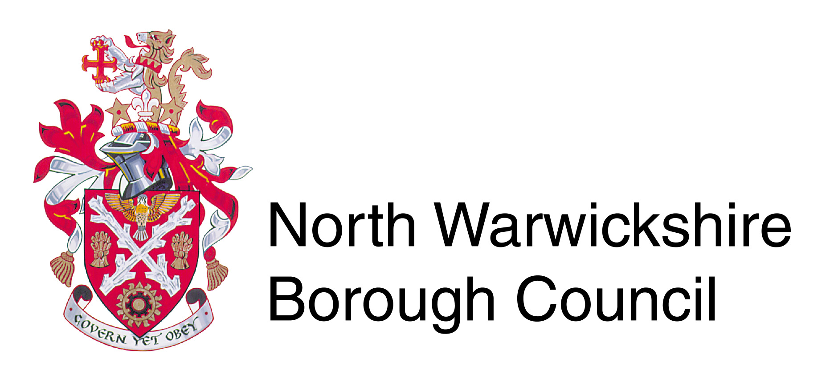

Application Form for Street Naming & Numbering 01 April 2024 – 31 March 2025

New single properties, which require postal addresses, should complete Sections ‘A’ & ‘B’

Existing PAF registered properties, which require a name or number change, should complete Sections ‘A’ & ‘C’

New developments of more than one property, should complete Sections ‘A’ & ‘D’

To register a commercial/business address, please complete Sections ‘A’ & ‘E’

Address query/problem eg. Property not registered or incorrect details held on the Royal Mail Postal Address File (PAF database), please complete Sections ‘A’ & ‘F’

Section A

Please provide details to which correspondence is to be sent:

Name:
Address:

Postcode: Tel:

E-mail:

Date:

Section B – Planning Application Number PAP/_ _ _ _/_ _ _ _

Please note – New properties will be numbered where necessary and letter suffixes added to infill development (eg. 3A)

If required, proposed name of property:

(We will consult with Royal Mail to ensure that there is no duplication in the area)

Please provide a map showing the location of the property.

Section C

Existing property name changes may take place if

- You are the owner of the property. If you are not, then you will need to provide written confirmation from the owner.

- The current nameplate does not form part of the structure

Current name of property:

Proposed name of property:

2nd Choice: 3rd Choice:

(We will consult with Royal Mail to ensure that there is no duplication in the area)

Please provide a map showing the location of the property.

Section D – Planning Application Number PAP/_ _ _ _/_ _ _ _

Developers of sites of more than one property need to send in a location plan and a site layout plan showing the plot numbering. If the development includes the need for new street/road names then please provide three suggestions in order of preference, together with the reasons for the choice of name/s

1)

2)

3)

(We will consult with Royal Mail to ensure that there is no duplication in the area)

Section E

Please provide details of the proposed commercial/business address/es below:

Please provide a map showing the location of the premises to be registered.
Section F

Please provide details of the anomaly/problem with the address

Please provide a map showing the location of the property

Table of Charges
 | Fee
New Development (Residential and Commercial) | £145.00 application fee  + £40.00 per property
Amend a Development layout after confirmation  (per plot) | £40.00
Naming of a New Street | £190.00
Rename/Renumber a PAF registered property  (including adding a name) | £82.00
Correcting an address anomaly | £40.00
Confirmation letter to solicitors/others | £32.00

Payment can be made by cheque (made payable to North Warwickshire Borough Council)
or by card by telephoning our Contact Centre on 01827 715341 stating that you wish to pay for a Street Naming & Numbering application.

If you require any further information please contact:-

Street Naming & Numbering
North Warwickshire Borough Council
The Council House
South Street
Atherstone
CV9 1DE

Telephone: 01827 719277
E-mail: SNN@northwarks.gov.uk

Please return completed forms, plans and the appropriate fee where necessary to:

Street Naming & Numbering
North Warwickshire Borough Council
The Council House
South Street
Atherstone
CV9 1DE

